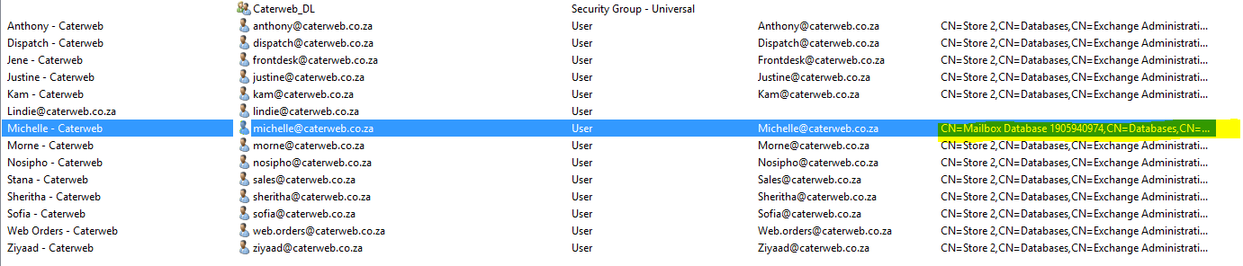
Desktop\ Notepad\ Commands Sizes
New-MoveRequest -Identity 'Michelle@caterweb.co.za' -TargetDatabase "Store 2" -Priority emergency

Get-MoveRequestStatistics -Identity Michelle@caterweb.co.za
Get-MoveRequest | remove-MoveRequest

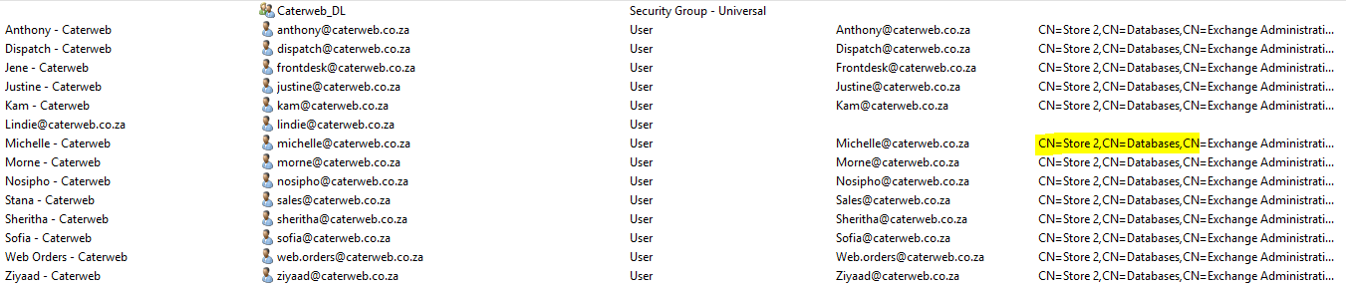
As almal op selfde db is, dan gaan jy na hc toe
Hcadmin
